SIB course: Protein sequence databases
Exam – March 2020
http://education.expasy.org/cours/SIB_UniProtKB_2020_exa/
First Name:
Last Name:

Question Protein sequence databases
From UniProtKB
- Look for the Candida Albicans reference proteome
What is the Proteome ID of the Candida Albicans Reference Proteome ?
To which strain does it correspond ?
How many proteins ?
How many Swiss-Prot entries ?
How many TrEMBL entries ?
How many proteins have been proved to exist at the protein level ? (Protein existence)
How many proteins with a transmembrane domain (KW Transmembrane) and a phosphohistidine?
Where does the information about the phosphohistidine site come from?

Question: Automated annotation
You have isolated in a screen protein Zgc:171429 (A8KB11_DANRE) from zebrafish (Danio rerio). Can you find out using HAMAP-Scan (https://hamap.expasy.org/) what kind of protein it is (Protein name?) and by which HAMAP annotation rule it will be annotated?
The following is an excerpt of the annotation rule:
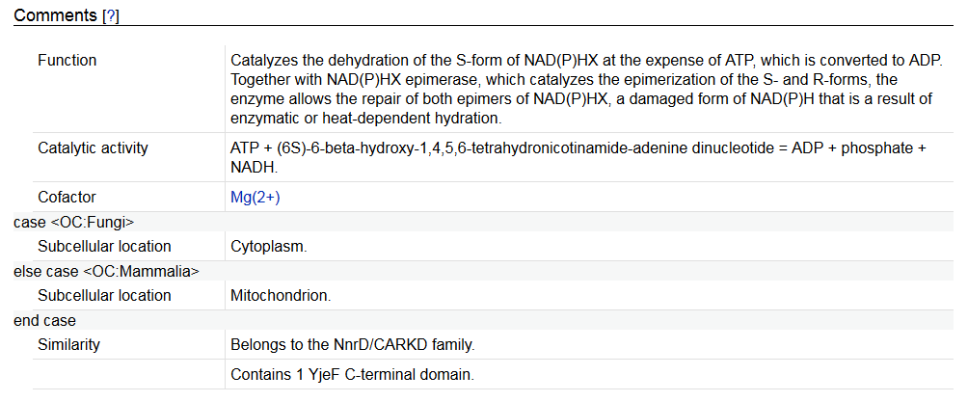
If you submitted A8KB11_DANRE to HAMAP Scan & Annotate, which subcellular location annotation would you find in the resulting protein annotation:
- Cytoplasm
- Mitochondrion
- Nothing

Question: How to mine enzyme data ?
Enzyme-catalysed reactions are annotated in UniProtKB in the Function / Catalytic activity section, using the Rhea annotation (at pH 7.3)
Biological context: Trimethylamine (TMA) is produced by the gut microbiome from dietary choline. TMA is then absorbed and converted to the pro-atherogenic molecule trimethylamine N-oxide (TMAO).
Find the bacteria and the human enzymes involved in the reactions.
- Use the compounds names
- Use the InChIKey (ChEBI)

Beware the pH and the names / synonyms of the different compounds.

